



PARLIAMENTARY PROCEDURE CONCEPTS ~TEAM~
(550)
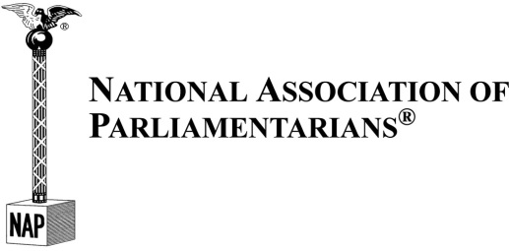
STATE 2021

TOTAL POINTS ____________100 Points

Test Time: 60 minutes

Questions are taken from Dunbar’s Manual of Parliamentary Procedure Test Questions (Fourth Edition, 18th Printing) as prescribed by the Workplace Skills Assessment Program guidelines for this event.
1 | B |  | 26 | B
2 | D |  | 27 | C
3 | B |  | 28 | B
4 | D |  | 29 | D
5 | B |  | 30 | B
6 | A |  | 31 | D
7 | C |  | 32 | C
8 | A |  | 33 | C
9 | B |  | 34 | D
10 | B |  | 35 | A
11 | B |  | 36 | D
12 | D |  | 37 | B
13 | A |  | 38 | C
14 | C |  | 39 | D
15 | C |  | 40 | D
16 | D |  | 41 | C
17 | C |  | 42 | C
18 | C |  | 43 | C
19 | C |  | 44 | D
20 | B |  | 45 | A
21 | A |  | 46 | C
22 | C |  | 47 | C
23 | C |  | 48 | A
24 | A |  | 49 | B
25 | A |  | 50 | C

